**CALIFORNIA STATE UNIVERSITY, Long Beach**

**Computer Science Department**

**CECS 543**

**Term project**

**“SIL”**

**Presented by:**

**Hashlamoun,Younes**

**Herman, Donald**

**Naumov,Mikhail**

**Instructor: Dr. Hoffman, Mechael**

**Fall 2010**

TABLE OF CONTENTS

List of features, 4

Class Diagram 5

I. Use cases 6

Use case GUI 6

Use case translate execute 7

II. Use Case Documentation 8

Begin…End Statement 8

Display error messages 8

Display Output 9

editing the program 9

Execute each statement 10

Execution of the program 10

Expressions 11

FOR Statement 12

Function declaration 13

Function declaration 13

Identifier 14

IF…Then Statement 14

Let Statement 15

Literal 16

Load file into memory 17

Obtain Input 17

Parse the program 18

Print Statement Reserved Word 18

PRINTLN Statement 19

Read a Token 20

Read Statement 20

Read a Token (Reserved) 21

Special characters 21

read/write symbol table 22

While Statement 23

Function Call 24

III. Sequence Diagrams 25

Display error message 25

Display Output 26

Editing the Program 27

Execution of the Program 28

28

Expressions 29

Function Call 30

Function Declaration 31

Identifier 32

IF then Statement 33

Let Statement 34

Literal 35

Load file into memory 36

Obtain Input 37

Parse the Program 38

Print Statement 39

Read a Token Reserved Word 40

Read a token 40

Read Statement 41

Symbol Table 42

Translate Statement 43

# List of features,

Our project’s features are very much fulfilling all the assignment’s requirements. Our application is unique in many features also, like we do parse the input file by reading the whole text then verify it’s syntax, if it passes with no errors, then we compile it or run it and send the expected output to the output screen.

Bellow is the list of features our application does have:

1. Two user interfaces, GUI we’ve got it as required, with main menu bar, status bar, input text window it can be multiple windows; one window for each file, output window and errors window.
2. Command prompt interface where you can pass the input file to be parsed as parameter argument to the application.
3. Capability of interpreting all SIL keywords determined at the assignment, INTEGER, BEGIN, END, IF THEN, LET, FOR , WHILE, FUNCTION AND OPERATORS.
4. Capability of interpreting nested if, for and while
5. Capability of evaluating mathematical expressions at any case, if used with let or print and at any level of complexity.
6. Capability of detecting and reporting syntax errors with line number and nature of the error before proceeding to execution.
7. Capability of detecting and reporting run time errors.

# Class Diagram

# Use cases

## Use case GUI

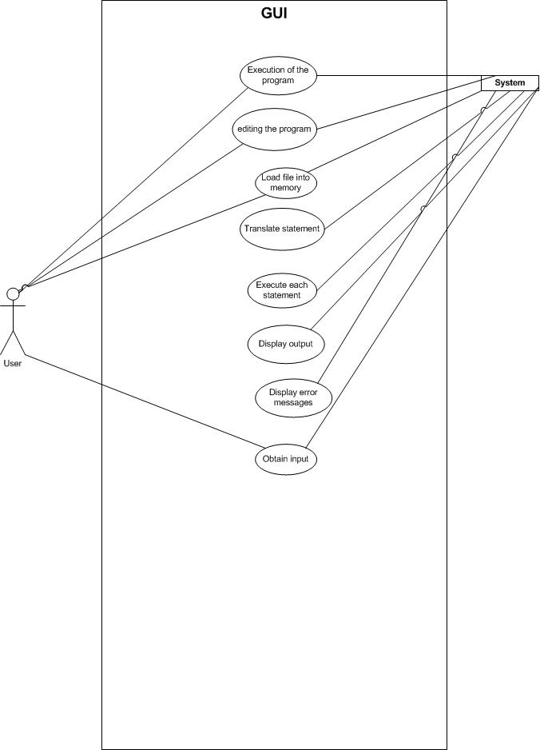

## Use case translate execute

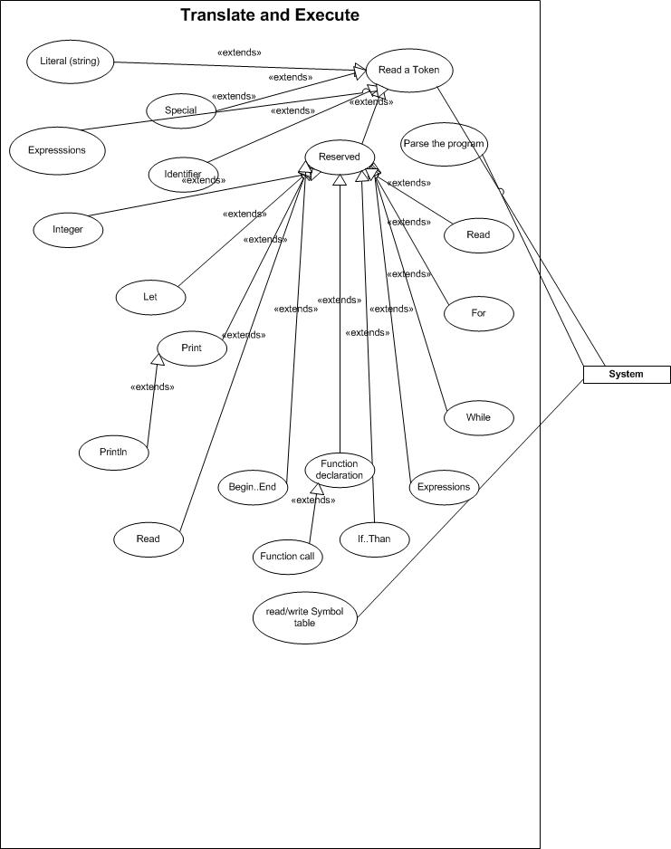

# Use Case Documentation

## Begin…End Statement

**Primary actor:** computer

**Goal in context:** This statement allows a series of statements to be executed as one.

**Preconditions:** computer has parsed the code

**Post Condition:** End Token has been reached

**Trigger:** computer encounters Begin token and the being event has fired.

**Scenario:**

|  |  |
| --- | --- |
|  | 1. Computer executes the remaining lines of statements |
|  |  |

**Exceptions:**

1.

## Display error messages

**Primary actor:** Computer

**Goal in context:** A syntax or run time error is displayed to the user.

**Preconditions:** program has been successfully parsed and is executing.

**Post Condition:** error window or command line has been updated

**Trigger:** A syntax or run time error has occurred.

**Scenario:**

|  |  |
| --- | --- |
|  | 1. Error message is passed as a string literal to the output windows of the correct user interface. |
|  | 1. If user interface is the GUI than the error message window’s text variable is updated |
|  | 1. If user interface is the command line than the error message is written to the command line. |

**Exceptions:**

1.

## Display Output

**Primary actor:** computer

**Goal in context:** Display the output of the computer program

**Preconditions:** Program has been successfully parsed and is executing.

**Post Condition:** Message has been displayed.

**Trigger:** A token that displays a message has been encountered

**Scenario:**

|  |  |
| --- | --- |
|  | 1. The command that display a message evaluates the string literal in question. |
|  | 1. The string literal that is displayed is passed the output windows |
|  | 1. If GUI is active than the output window’s display is update with the new string literal. |
|  | 1. If command Line is active than the string literal is displayed on the command line. |

**Exceptions:**

## editing the program

**Primary actor:** User

**Goal in context:** user can change the code in the program and save the file

**Preconditions:** file is open and displayed in the editor

**Post Condition:** file has been saved to disk.

**Trigger:** User clicks on open file.

**Scenario:**

|  |  |
| --- | --- |
| 1. User can add and delete characters in the editing window. | 1. Computer updates the information displayed in the editing window |
| 1. User selects file > save to save the edited file to disk | 1. Computer saves the new information in the editing windows to disk in the file specified. |

**Exceptions:**

1.

## Execute each statement

**Primary actor:** computer

**Goal in context:** computer executes each statement in the code.

**Preconditions:** code has been checked for syntax errors

**Post Condition:** computer has encountered END statement in the main method.

**Trigger:** first line has been encountered.

**Scenario:**

|  |  |
| --- | --- |
|  | 1. First line of code is encountered by computer and it is parsed. |
|  | 1. The token are checked and the proper methods are executed as needed. |

**Exceptions:**

1.

## Execution of the program

**Primary actor:** User

**Goal in context:** Running an Interpreted sim file.

**Preconditions:** sim file must be open

**Post Condition:** computer starting to execute the code.

**Trigger:** user selects run

**Scenario:**

|  |  |
| --- | --- |
| 1. User clicks on the run button. | 1. Computer starts to translate the file. |
|  |  |

**Exceptions:**

|  |  |
| --- | --- |
| 1. There is no file loaded; error message to shown please open a file. |  |
|  |  |

## Expressions

**Primary actor:** computer

**Goal in context:** Constants, identifies and arithmetic operators are used to complete a single integer value.

**Preconditions:** Code has been successfully parsed.

**Post Condition:** Expression method has returned a single integer value.

**Trigger:** When certain REVERED words (LET, IF, while, for) or a SPECIAL character is encounter by the computer.

**Scenario:**

|  |  |
| --- | --- |
|  | 1. When a special character is found the following token in the lineup until a terminator token (then, end of line, comma) are used as parameters for the expression method. |
|  | 1. Leading token is compared against a switch statement of special characters. |
|  | 1. Second Token is computed by Solution integer value according to the special character. (Example Token is 1, special character is +, solution integer is 5, new solution integer is 1 + 5 = 6.) |
|  | 1. If Token is an identifier when obtain value from Symbol Table. |
|  | 1. Remaining tokens and Solution integer is passed to the expression method recursively. |
|  | 1. This recursion continues as long as tokens remain in the container of tokens. |
|  | 1. The solution integer is returned when all tokens are used. |

**Exceptions:**

1.

2. Token doesn’t match any items in the switch statement Synax error message is displayed ”Expression is invalid Line #X.”

3. If SPECIAL symbol is divide (/) and the token is zero. Computer returns a run time error “Divide by zero Line#”.

## FOR Statement

**Primary actor:** computer

**Goal in context:** The FOR Statement allows execution of the following statement block (between begin … end blocks) until a counter is exceeded.

**Preconditions:** Program has been successfully parsed.

**Post Condition:** Block statement has been executed the specified number of times.

**Trigger:** The computer encounters the FOR token and FOR statement event is triggers.

**Scenario:**

|  |  |
| --- | --- |
|  | 1. The tokens following the FOR token until the END state are passed to the FOR method in a container of tokens. |
|  | 1. The first token or series of tokens are used to set the initial value for the counter until the DO toke is encountered. |
|  | 1. The next sets of tokens are used to set the terminator for the counter until the DO token is encountered. |
|  | 1. The statements following the BEGIN token is executed as normal. |
|  | 1. Once the END token is encountered the counter is incremented by one and compared to the terminator. If less than the terminator than goto step #4. |
|  | 1. Once terminator has been reach the computer will skip the following begin end block. |

**Exceptions:**

2. Token or series must be a real number else syntax error is encountered and computer displays “Error real number must be used line # X.”

3. Token or series must be a real number else syntax error is encountered and computer displays “Error real number must be used line # X.”

## Function declaration

**Primary actor:** computer

**Goal in context:** A function name is encountered that has been added to the hash table of reserved word.

**Preconditions:** The computer has successfully parsed the code and the main part of the application program is running.

**Post Condition:** function end statement has been encountered.

**Trigger:** computer encounters a function name and the function event is triggered.

**Scenario:**

|  |  |
| --- | --- |
|  | 1. Parameters are passed to the function event |
|  | 1. The line of code in the function are executed as normal |

## Function declaration

**Primary actor:** computer

**Goal in context:** A function name is added to the harsh table of Reserved word and the statements in between the begin … end block are added to the event manager under the function name.

**Preconditions:** The computer has successfully parsed the code.

**Post Condition:** function statement have been added to the event manager as an event.

**Trigger:** computer encounters a function token and the function event is triggered.

**Scenario:**

|  |  |
| --- | --- |
|  | 1. Tokens following the “function” token are passed to the function event ending with the END token. |
|  | 1. The first token is the identifier and is added to the event manager hash table |
|  | 1. The remaining tokens are stored in a function object as a container of tokens. |

**Exceptions:**

1. If a “begin” or “function” token is encountered before the “end” token than the program terminates with a syntax error ” must enclose block with begin and end line #”
2. If hash table already contains the identifier than the computer terminates and then displays the syntax error message “function has already been declared.”
3. Tokens must be checked for list of parameters
   1. The first token must be a opening parentheses

## Identifier

**Primary actor:** computer

**Goal in context:** Identifier identifier value can obtain in constant time from Hash Table (symbol table).

**Preconditions:** code is being interpreted and executed.

**Post Condition:** Identifier value has been returned.

**Trigger:** interpreter has encountered identifier token and the identifier method event has fired.

**Scenario:**

|  |  |
| --- | --- |
|  | 1. Identifier from symbol table is looked up using hash code algorithm. |
|  | 1. Identifier value is returned |

**Exceptions:**

1. If identifier has not been declared than program stops and a syntax error is displayed “Identifier has not been declared line # X”

## IF…Then Statement

**Primary actor:** computer

**Goal in context:** Allows SIL code to conditionally execute a statement.

**Preconditions:** code is parsed successfully

**Post Condition:** conditional statement is executed or skipped.

**Trigger:** Token containing the reserved word “ IF” is encountered.

**Scenario:**

|  |  |
| --- | --- |
|  | 1. When IF token is encountered event is triggered and the IF..Then method is called. |
|  | 1. All token are assume to be a valid relational expression before the then statement |
|  | 1. Relational expression event is triggered and the expression method is called. |
|  | 1. The Relational expression method returns a Boolean value. |
|  | 1. If Boolean value from step #4 is true than the statement line after the THEN token is executed |
|  | 1. If Boolean value from step #4 is true than the statement line after the THEN token is not executed. |

**Exceptions:**

1.

2. If THEN token is missing than the computer displays a syntax error “incomplete IF THEN Statement” and line #

3. If Relational expression divides by zero than a run time error displayed “Divide by Zero” Line #.

## Let Statement

**Primary actor:** computer

**Goal in context:** Let Statement will assign a value to a variable using an expression

**Preconditions:** Interpreter encounters token is the Let reserved word.

**Post Condition:** Symbol Table variable value is updated.

**Trigger:** Let reserved word triggers event to fire.

**Scenario:**

|  |  |
| --- | --- |
|  | 1. All tokens in the Let line are passed to the Let method. |
|  | 1. The first token is assumed to be a variable in Symbol Table. |
|  | 1. The expression is evaluated using the expression methods. |
|  | 1. The variable is updated to the new value returned by the expression method. |

**Exceptions:**

**2.** If the Symbol Table doesn’t contain the variable a Syntax error is displayed and the program stops executing.

**3.** If the Expression divides by zero than a run time error is displayed and the program stops running.

## Literal

**Primary actor:** computer

**Goal in context:** The handling of Literals by the interpreter.

**Preconditions:** code is being interpreted and executed.

**Post Condition:** Literal has been displayed on screen.

**Trigger:** A double quote token has been encountered.

**Scenario:**

|  |  |
| --- | --- |
|  | 1. Token following the double quote are treated as the same Literal |
|  | 1. Second double quote token is encountered and treated as the end of the Literal. |

**Exceptions:**

2. If no second double quote is encountered before end of line than program terminates with Syntax error “Literal must be enclosed by quotes Line # x”

## Load file into memory

**Primary actor:** user and system

**Goal in context:** File isselected by user and loaded into memory for editing andexecuting.

**Preconditions:** SIL GUI is loaded and running.

**Post Condition:** file is open and displayed on the GUI screen

**Trigger:** User selects file > open from GUI menu

**Scenario:**

|  |  |
| --- | --- |
| 1. User selects *.sim file and clicks open | 1. Computer displays file in the editing window |

**Exceptions:**

|  |  |
| --- | --- |
| 1. User selects a non sim file; file should be opened as if it was a sim file. |  |

## Obtain Input

**Primary actor:** User and Computer

**Goal in context:** Obtain input from the user in order to update an Identifier’s value

**Preconditions:** Code has been parsed and is running.

**Post Condition:** User has finished inputting data.

**Trigger:** An input method has been triggered.

**Scenario:**

|  |  |
| --- | --- |
|  | 1. Computer display curser on the output screen according to the User interface |
|  | 1. If GUI is user interface than the output windows display the curser. |
|  | 1. If command line is user interface than the command line displays the curser. |
| 1. User input value into the UI and a carrier return. | 1. Computer takes value from user input and stores it in memory. |
|  | 1. The variable value is updated in the Symbol table. |

**Exceptions:**

4. If user inputs a none real number than the program with terminate with a syntax error. “Input must be a real number line #.” Application programmer must check for correct input and let the user retry in order for program to not crash.

## Parse the program

**Primary actor:** computer

**Goal in context:** SIL file will be parse line by line to collect and analyzed each token as needed.

**Preconditions:** SIL file is load and run.

**Post Condition:** Entire file is successfully parsed.

**Trigger:** User clicks on run

**Scenario:**

|  |  |
| --- | --- |
|  | 1. File is open using STL file reader |
|  | 1. First line is parsed using space as a delimiter. Each token is stored in an index of an array of string. |
|  | 1. Each token is stored in an index of an array of strings. |
|  | 1. The first token is compared against a hash table of REVERED words. |
|  | 1. An event is created and the parameters, type and line number of the event are stored. |
|  | 1. Step 4 to 10 are repeated for each line number. |

**Exceptions:**

|  |  |
| --- | --- |
|  | 8. If token is not a REVERED word than exception is created. |
|  |  |

## Print Statement Reserved Word

**Primary actor:** computer

**Goal in context:** Execute print command

**Preconditions:** Code has been parsed and a reserved word has been found.

**Post Condition:** literal is displayed

**Trigger:** Computer finds reserve word and event is fired.

**Scenario:**

|  |  |
| --- | --- |
|  | 1. Print method is executed and the rest of the tokens are passed to the method. |
|  | 1. If next token is an expression the expression event is fired. |
|  | 1. Expression is displayed |
|  | 1. If token is Literal it is displayed |
|  | 1. Step 2 to 4 are continued until all the token have been evaluated. |

**Exceptions:**

1. If expression divides by zero a run time error is display “divide by zero Line #” X and the program terminates.

## PRINTLN Statement

**Primary actor:** computer

**Goal in context:** All items expression and literals are displayed with a carrier return.

**Preconditions:**  Code has been parsed

**Post Condition:** computer has finished displaying all the literals, expressions and displayed a new line

**Trigger:** PRINTLN token isencountered by the computer

**Scenario:**

|  |  |
| --- | --- |
|  | 1. Print method is executed and the rest of the tokens are passed to the method. |
|  | 1. If next token is an expression the expression event is fired. |
|  | 1. Expression is displayed |
|  | 1. If token is Literal it is displayed |
|  | 1. Step 2 to 4 are continued until all the token have been evaluated. |
|  | 1. Carriage return and newline are displayed. |

**Exceptions:**

1. If expression divides by zero a run time error is display “divide by zero Line #” X and the program terminates.

## Read a Token

**Primary actor:** Computer

**Goal in context:** Compares parsed token and executes appropriate commands

**Preconditions:** Line of code has been parsed by compiler.

**Post Condition:** Token has been compared to list of tokens.

**Trigger:** new line of code is encountered.

**Scenario:**

|  |  |
| --- | --- |
|  | 1. Parsed Token is compared against hash table of Tokens |
|  | 1. If token is found in table than appropriate commands are executed (see use cases that extends this use case) |
|  |  |

**Exceptions:**

1. If token is missing than execution is displayed to user with command line #. Code is not executed.

## Read Statement

**Primary actor:** Computer

**Goal in context:** This command allows user input to be saved in a variable.

**Preconditions:** Code has been parsed and code is running.

**Post Condition:** variable has been updated.

**Trigger:** A “READ” token has been encountered and the READ event has been triggered.

**Scenario:**

|  |  |
| --- | --- |
|  | 1. User is prompted to input data |
|  | 1. User input is obtained |
|  | 1. Variable is updated with user input |

**Exceptions:**

2. If user input is not a number than a run time error will be displayed. Ideally Application programmer must check for errors.

## Read a Token (Reserved)

**Primary actor:** computer

**Goal in context:** actions that Interpreter takes when encountering a Reserved Token

**Preconditions:** Code has been Parsed by the computer

**Post Condition:** Computer has finished executing the line of code

**Trigger:** Token read is a “Reserved” Token

**Scenario:**

|  |  |
| --- | --- |
|  | 1. Token is compared to hash table of reserved words |
|  | 1. If match is found event is triggered |

**Exceptions:**

1. If reserved word is not found Token is assumed to be a Identifier

## Special characters

**Primary actor:** computer

**Goal in context:** Special characters used in IF…Then , Let and expressions Commands

**Preconditions:** code is being interpreted and executed.

**Post Condition:**

**Trigger:** Special character token is encountered by the token

**Scenario:**

|  |  |
| --- | --- |
|  |  |
|  |  |

**Exceptions:**

1.

## read/write symbol table

**Primary actor:** computer

**Goal in context:** add item to the symbol table and read and write to them

**Preconditions:** code is being interpreted and executed.

**Post Condition:** value is returned or symbol table is updated.

**Trigger:** INTEGER token is encountered by interpreter

**Scenario:**

|  |  |
| --- | --- |
|  | 1. Token found by the interpreter after the integer statement are added to the symbol table |
|  | 1. If Token is not a reserved word it is assumed to be a INTEGER and the its value in the symbol table is return |
|  | 1. If token after integer is an assignment token than value assign will be added to the symbol table. |

**Exceptions:**

1. If token is already found in the symbol table than Compile error is generated “identifier is already in the symbol table.”
2. If value is NULL than a Compile error is generated “identifier has null have value assigned.”
3. If value is not an integer value than a Compile error is generated “identifier has null have value **Use case:** Translate statement

**Primary actor:** computer

**Goal in context:** computer translates the statement of the program

**Preconditions:** user has clicked on run and has a file open

**Post Condition:** line has finished executing.

**Trigger:** user has click on run.

**Scenario:**

|  |  |
| --- | --- |
|  | 1. Tokens encountered by the computer are analyzed |
|  | 1. Proper methods are executed according to the tokens encountered. |

**Exceptions:**

1.

## While Statement

**Primary actor:** computer

**Goal in context:** statement line below the while statement continually executed until while the expression is true

**Preconditions:** code has been parsed successfully.

**Post Condition:** expression is false and statement is skipped.

**Trigger:** computer encounterstoken that is a WHILE statement and event is triggered.

**Scenario:**

|  |  |
| --- | --- |
|  | 1. All tokens following the while token and before the DO token are considered part of the relational expression. These token are passed as a container of strings to the relational expression method. |
|  | 1. If than relation expression is true than the statement below the while . do is executed. If condition is false do to step 4. |
|  | 1. Steps 1 and 2 are continued. |
|  | 1. Statement below while .. do is not executed. |

**Exceptions:**

2. If relational expression divides by error than computer displays message. Run time error” divide by zero line #”

## Function Call

**Primary actor:** computer

**Goal in context:** Executing afunction using the values in the specified parameters.

**Preconditions:** code has been successfully parsed by the computer, and main body of programming is been executed.

**Post Condition:** Function END token has been encountered.

**Trigger:** Token of function Identifier is encountered and function event is triggered.

**Scenario:**

|  |  |
| --- | --- |
|  | 1. Tokens starting from the open parenthesis to a closed parenthesis are passed to the event |
|  | 1. The numbers of tokens between the parenthesis are compared to the parameter list. |
|  | 1. A BEGIN token is encounter in the function. |
|  | 1. Each statement after the begin token is executed. |
|  | 1. When the return Token is encountered the function event terminates. |
|  | 1. An integer value is returned. |

**Exceptions:**

1. If the paraphrases are missing than an syntax error is displayed. “Missing parenthesis. Line # x”
2. If the number of token in the function call don’t match the declaration than the computer stops and a syntax error is displayed. “Incorrect # of parameters. Line # x”
3. If a begin token is not encountered than the program terminates and a syntax error is displayed. “Missing begin token in function line # X”
4. If ”end” token is encountered before “return” token program terminates and syntax error message is displayed “Missing return token in function line # X”
5. If none integer value is retuned example “string” than program terminates and syntax error message is displayed “Missing return return integer value in function line # X”

# III. Sequence Diagrams

## Display error message

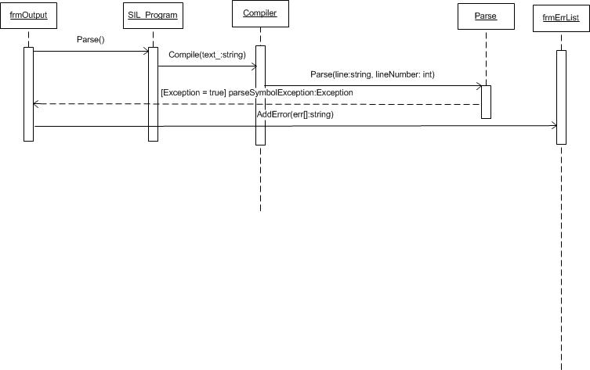

## Display Output

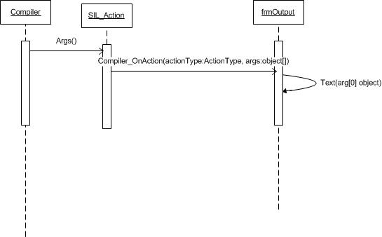

## Editing the Program

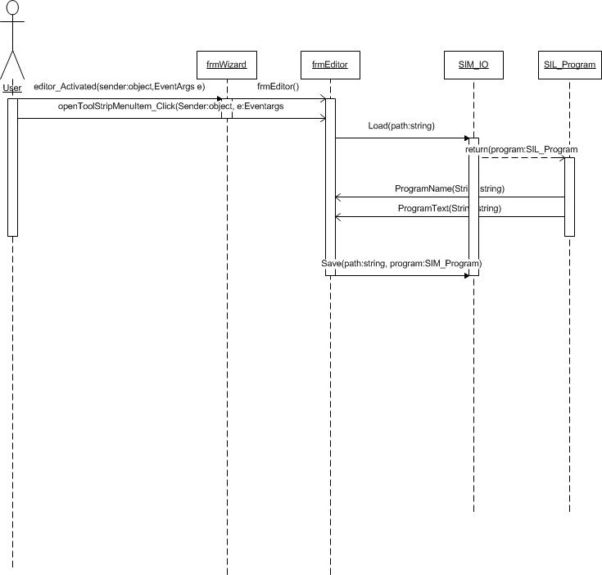

## Execution of the Program

## 

## Expressions

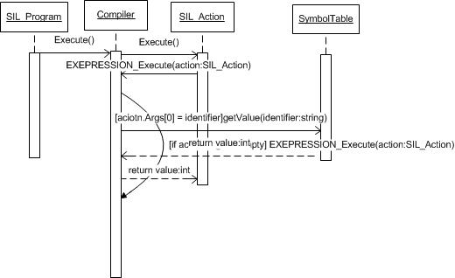

## Function Call

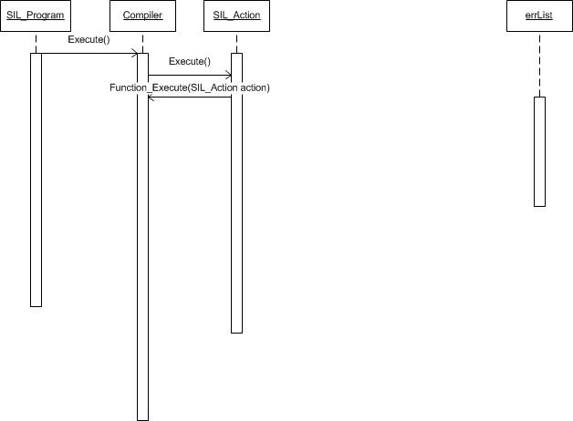

## Function Declaration

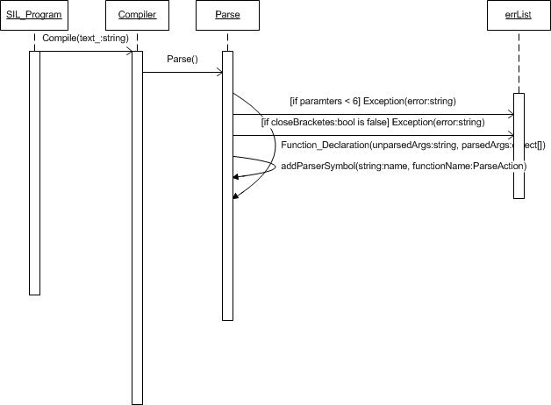

## Identifier

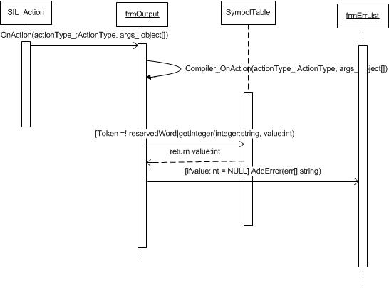

## IF then Statement

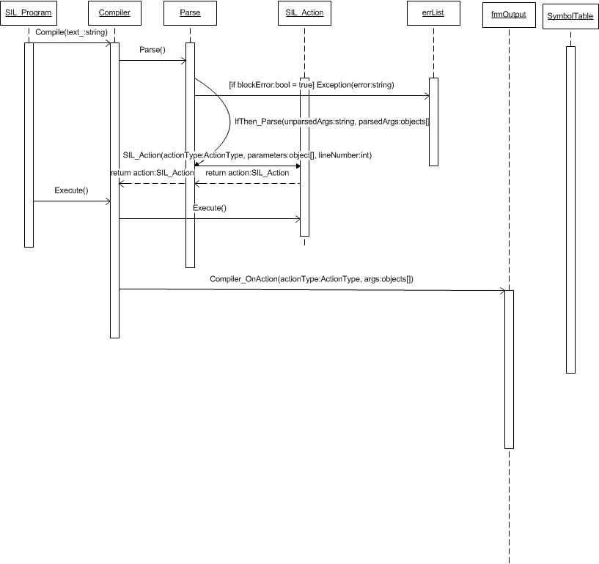

## Let Statement

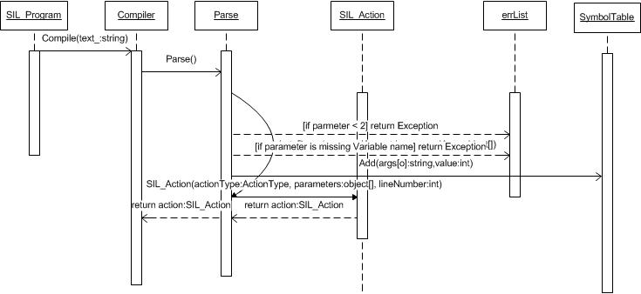

## Literal

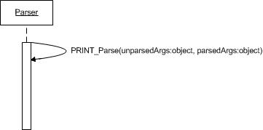

## Load file into memory

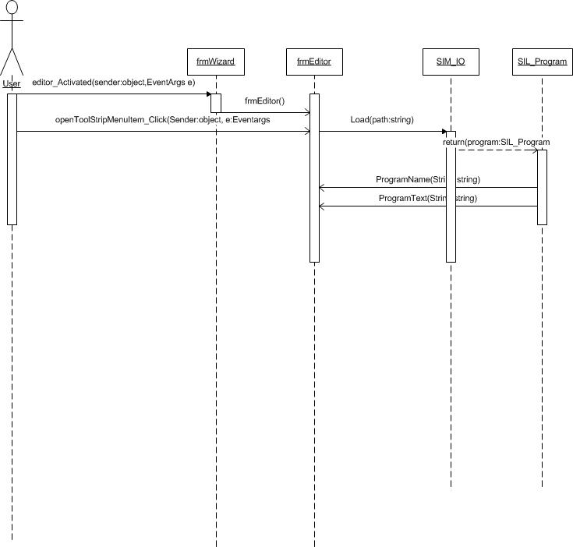

## Obtain Input

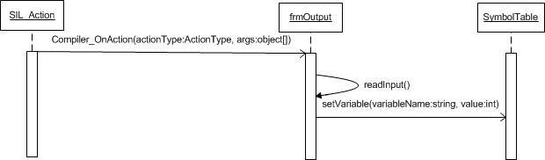

## Parse the Program

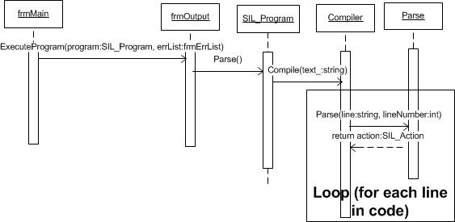

## Print Statement

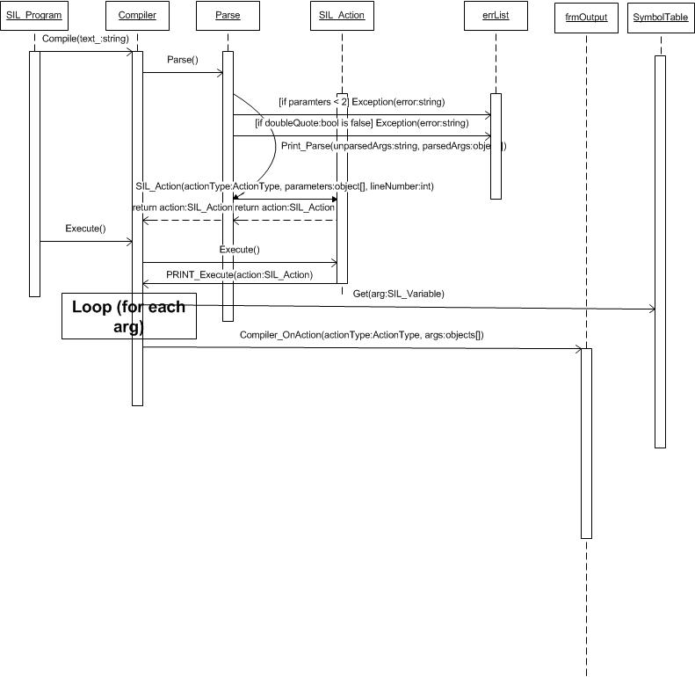

## Read a Token Reserved Word

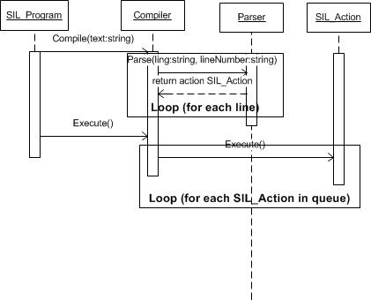

## Read a token

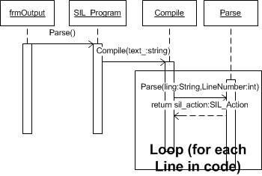

Read Statement

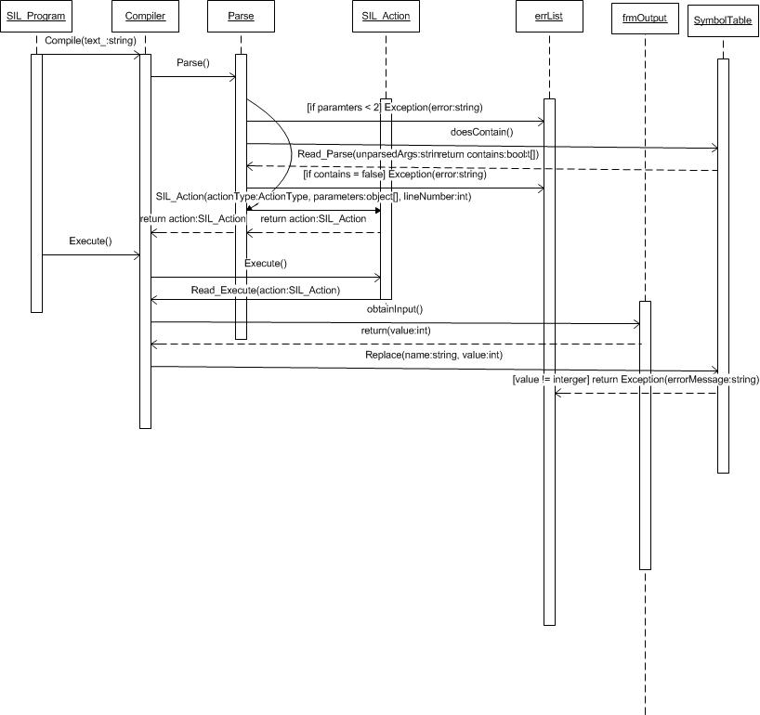

Symbol Table

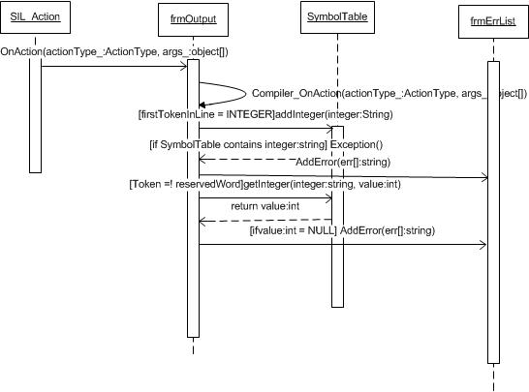

## Translate Statement

